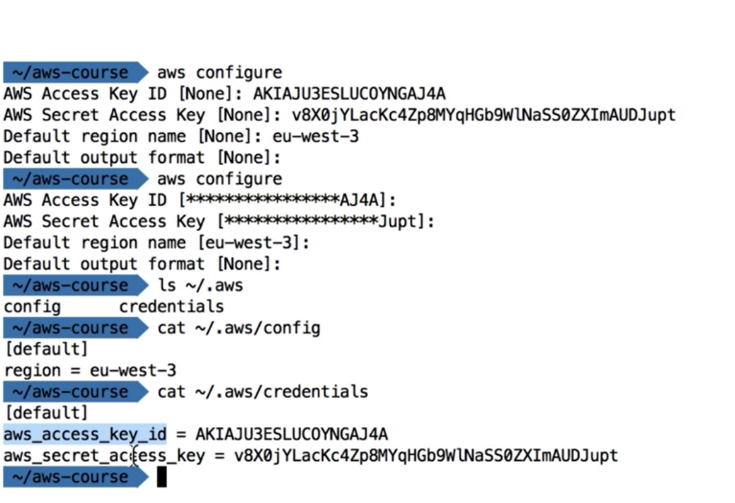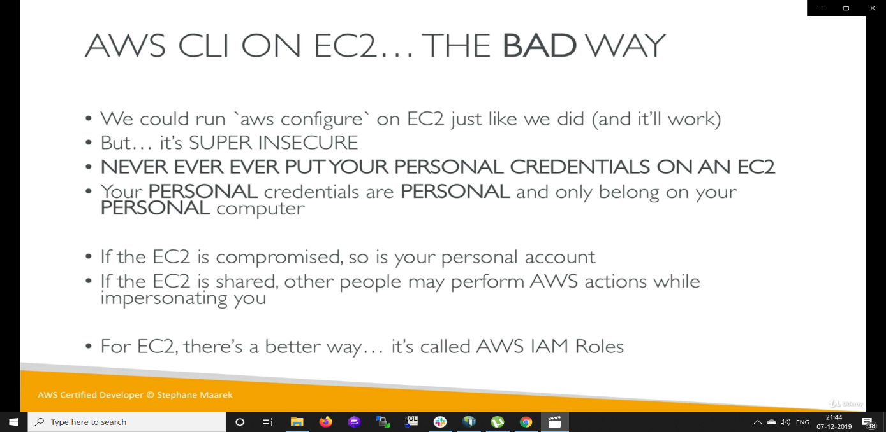
We can ause multiple aws accounts in cli by using following commands
- Aws configure –profile aws-acc1
- Enter all credentials
- Aws s3 –profile aws-acc1
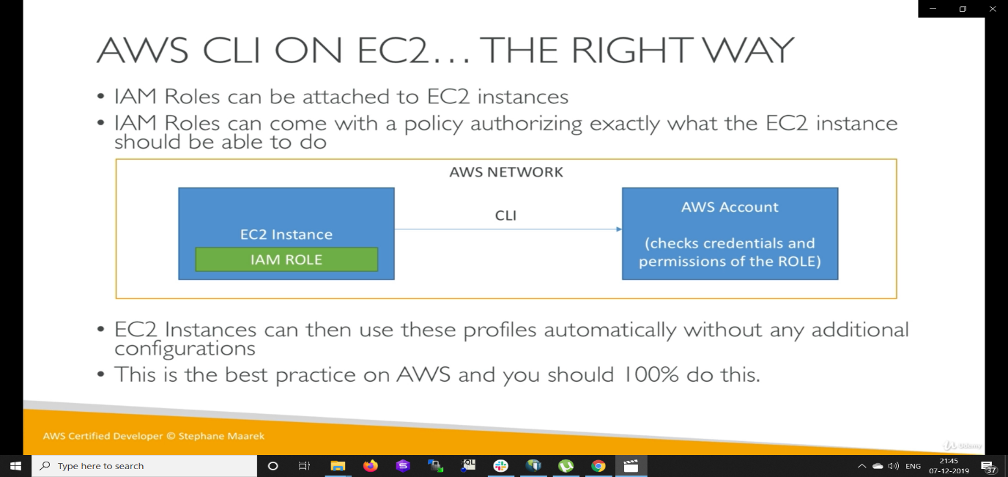
- Never ever add credentials of aws in ec2 machine with >aws configure. Instead add role to access those service from ec2 instance
- No need to install aws cli in ec2 machines. > Aws configure > Add only region
- Then create a role of ec2 instances in IAM and add permissions to s3 Readonlyaccess
- Then go to the ec2 management console. Right click on the instance that you want to add this.>instance settings>attach/replace a role
- Now type a command >aws s3 ls
- In roles we can add policies, also there is an option of adding inline policy which is not recommended
- We can our create own policies in policies tab that can provide access on specific bucket/ object show below
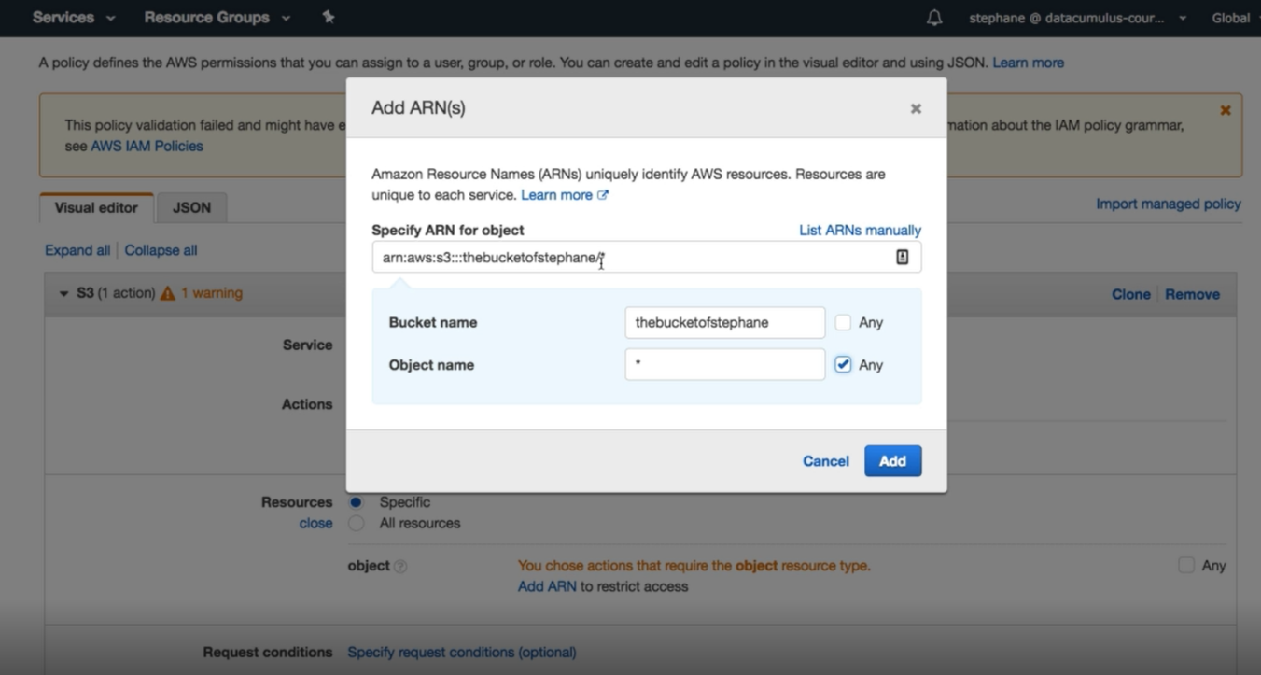

There is Aws policy simulator where we can opt one policies and test them on simulator as shown below

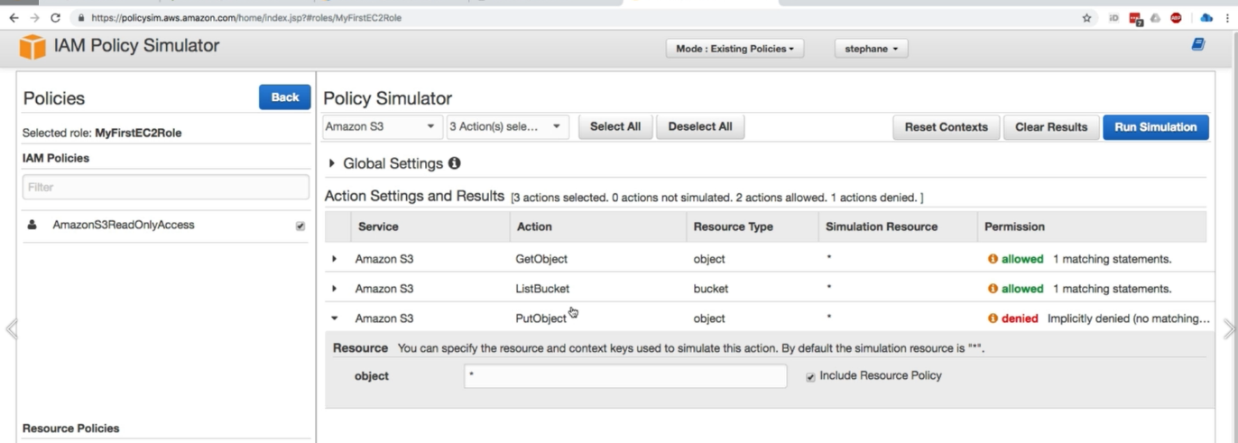

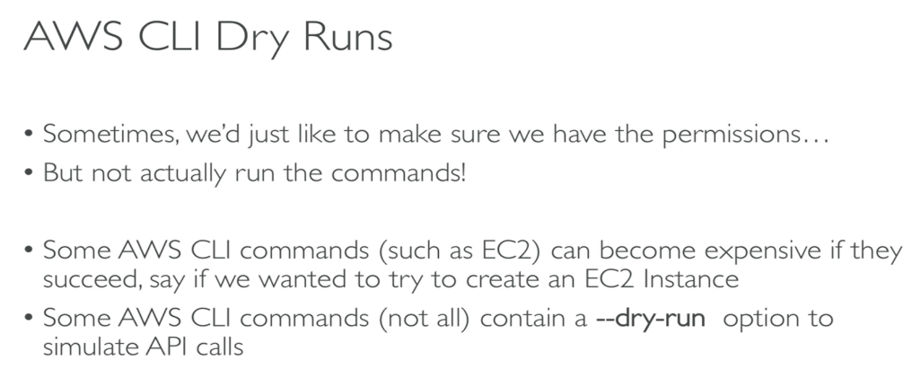
STS
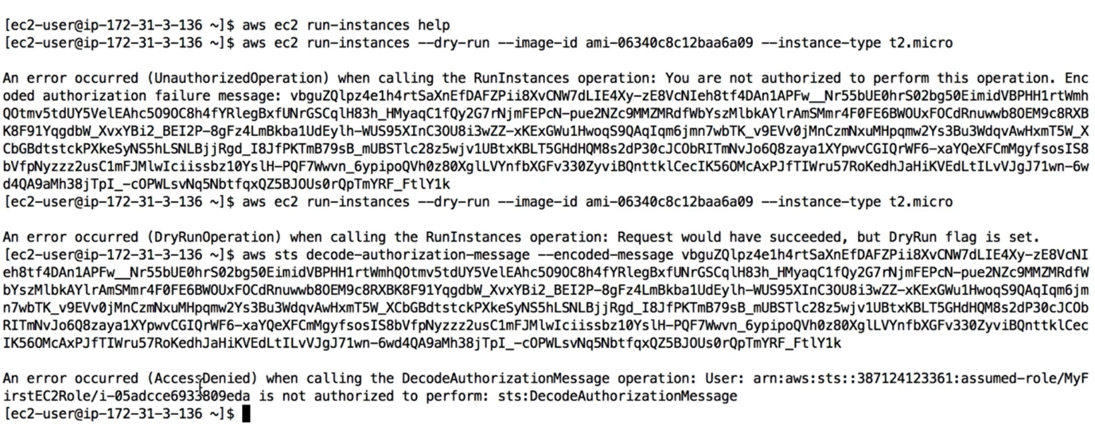
- Inorder to decode the error message we can use the command as above/ we can add an sts permission policy (read/write) - decodeAuthorization message
- From then onward we will get full data and error description
AWS Metadata
- It allows EC2 instances to know about themselves
- The Url is http://169.254.169.254/latest/meta-data
- It retries only IAM role name but not IAM policies
- Metadata = EC2 Info
- Userdata = Launch script
Note: By default aws sdk uses US-EAST-1 as region if not specify
AWS SDK Credentials Security
- It is recommended to use the default credential provider chain
- AWS credentials at ~/.aws/credentials (only on computer and on premise)
- Instance profile credentials using IAM roles ( for ec2 machines)
- Environment variables (AWS_ACCESS_KEY_ID,AWS_SECRET_ACCESS_KEY)
Exponential Backoff: Any api call failure because of too many calls need to be retried with Exponential Backoff. aws sdks hit aws api fail> Waits 10ms faill>20ms fail> 40ms fail> 80ms fail…
BeanStalk:

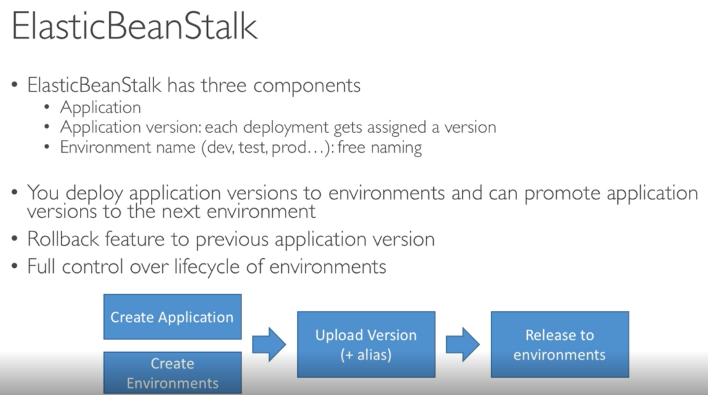

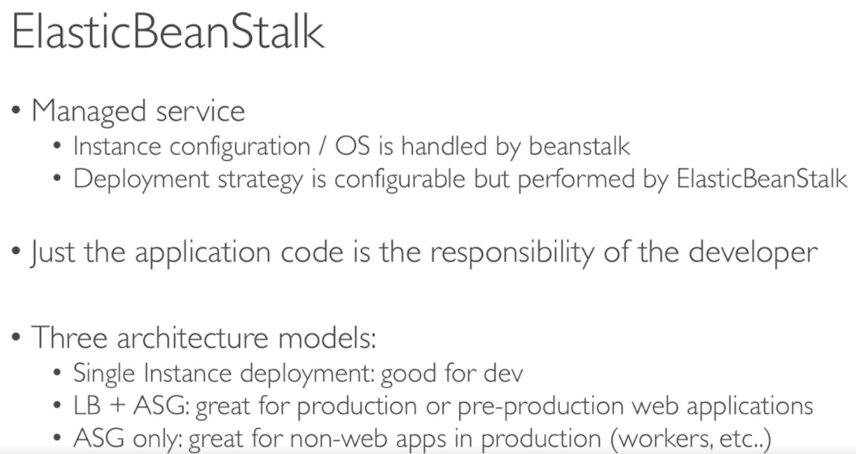

When we deploy a code and select a platform, beanstalk will create resources based on env and availability configuration a) single instance deployment b) LB+ASG c) only ASG (used for workers)
- S3 bucket for environment data
Elastic IP
EC2 Instance
ASG
Security groups for free tied that you can see all the events happened in below picture
Its better use own RDS rather than configuring in beanstalk since it gets delete on beanstalk deletion.
- We can handle that by enabling deletion protection in RDS
- Take a snapshot of RDS for disaster recovery
- Create new beanstalk env with out RDS
- Perform blue/green deployment and swap env
- Terminate old env
- Delete cloud formation stack manually since deletion of RDS is failed
Underhood, beanstalk depends on cloud formation
Can load SSL certificate in load balancer of eb console or can be done from code too (.ebextension/securelistener-alb.config) and must configure security group to allow 443
Beanstalk redirect http to https
- Configure instance to redirect Http to Https
- Configure ALB only with rule
- Make sure health checks are redirected else they keep giving 200 OK
Beanstalk lifecycle policy
- Can store 1000 application versions
- Need to remove old versions else cannot deploy anymore when loaded
- To phase out old application versions use lifecycle policy
- Based on time (old versions are removed)
- Based on space (when there are more versions
Consist of a single ZIP file or WAR file (you can include multiple WAR files inside your ZIP file) and bundle should not exceed 512 MB.
If you want to deploy a worker application that processes periodic background tasks, your application source bundle must also include a cron.yaml file
EB CLI can be used to work with elastic beanstalk
current environment should not be changed- immutable since it creates new env
custom Elastic Beanstalk environment- you can specify an Amazon Machine Image (AMI) to use instead of the standard Elastic Beanstalk AMI included in your platform version. A custom AMI can improve provisioning times when instances are launched in your environment if you need to install a lot of software that isn't included in the standard AMIs or lot of configuration files and patches that need to be download.
Have a roll back feature
Elastic Beanstalk periodically updates its platforms with new software and patches using rolling updates in batches. Elastic Beanstalk doesn't upgrade running environments to new platform versions automatically, but you can initiate a platform update to update your running environment in place. configuration of the environment that change can be made in-place
Deleting an application version doesn't affect environments currently running that version.
You can also configure Elastic Beanstalk to delete old versions automatically by configuring application version lifecycle settings. If you set a maximum age of 90 days, any versions older than 90 days are deleted when you upload a new version.

With the AWS Elastic Beanstalk Compose Environments API, you can create and update groups of Elastic Beanstalk environments within a single application where links also can be created in corresponding env.yaml file for internal communication of services
Default values that are applied automatically by Elastic Beanstalk override these defaults with configuration files, saved configurations, command line options, or by directly calling the Elastic Beanstalk API
You can't configure enhanced health to ignore other HTTP errors in addition to 4xx.
Elastic Beanstalk doesn't turn on default encryption for the Amazon S3 bucket that it creates
The EB CLI looks for credentials and configuration settings in the following order
- Command line options
- Environment variables – AWS_ACCESS_KEY_ID and AWS_SECRET_ACCESS_KEY
- The AWS credentials file – Located at ~/.aws/credentials
- The AWS CLI configuration file – Located at ~/.aws/config
- Legacy EB CLI configuration file – Located at ~/.elasticbeanstalk/config
- Instance profile credentials
https://docs.aws.amazon.com/elasticbeanstalk/latest/dg/troubleshooting.html
Dockerrun.aws.json is used for multi container deployment. Don’t use docker-compose when this file is used. Both docker and Dockerrun.aws.json can be used. Image from docker file has high weightage.
can modify default settings using option_settings

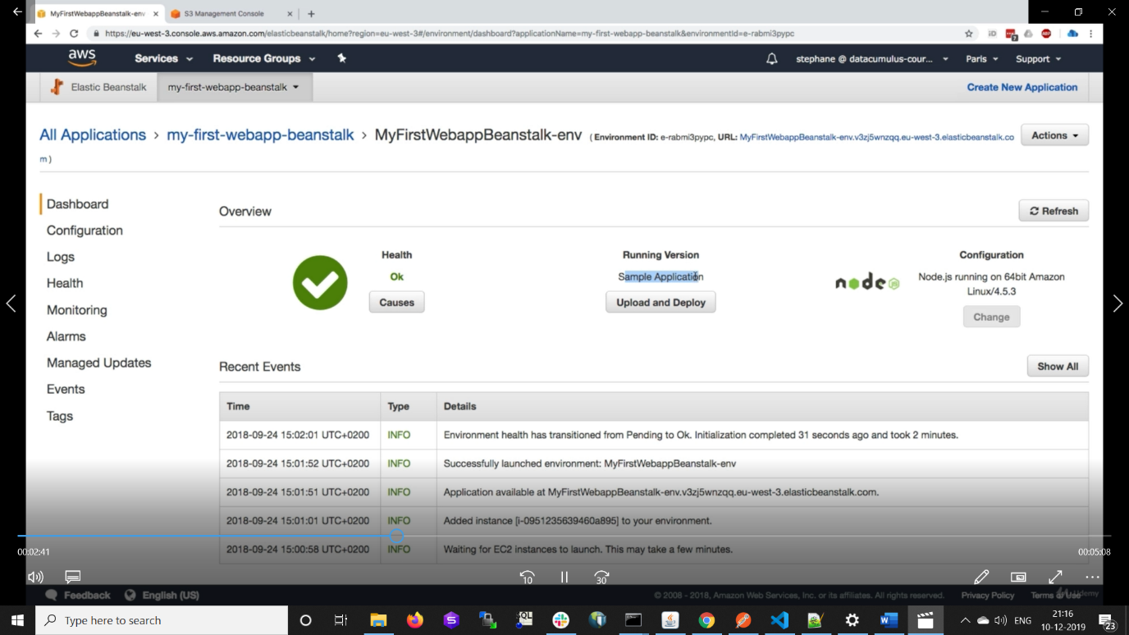
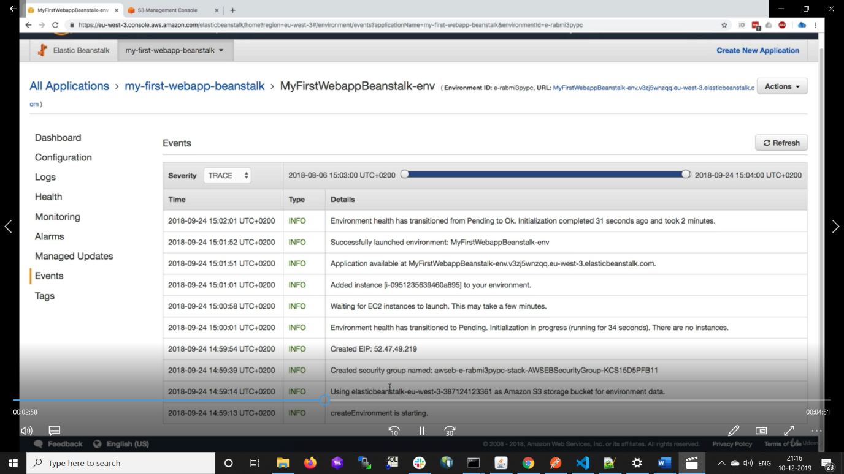
For paid tier ASG,ELB,security groups etc are created

Environment
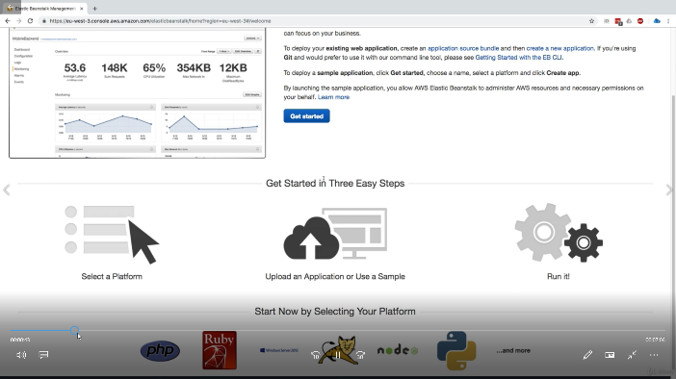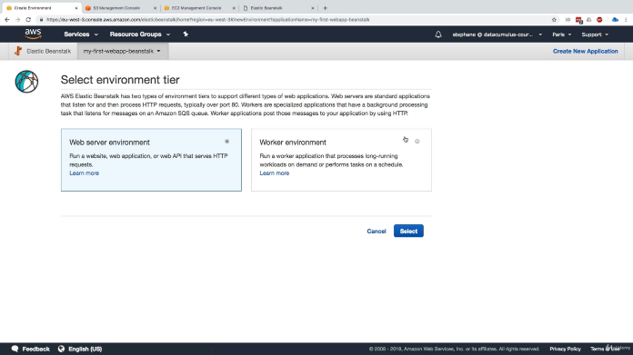
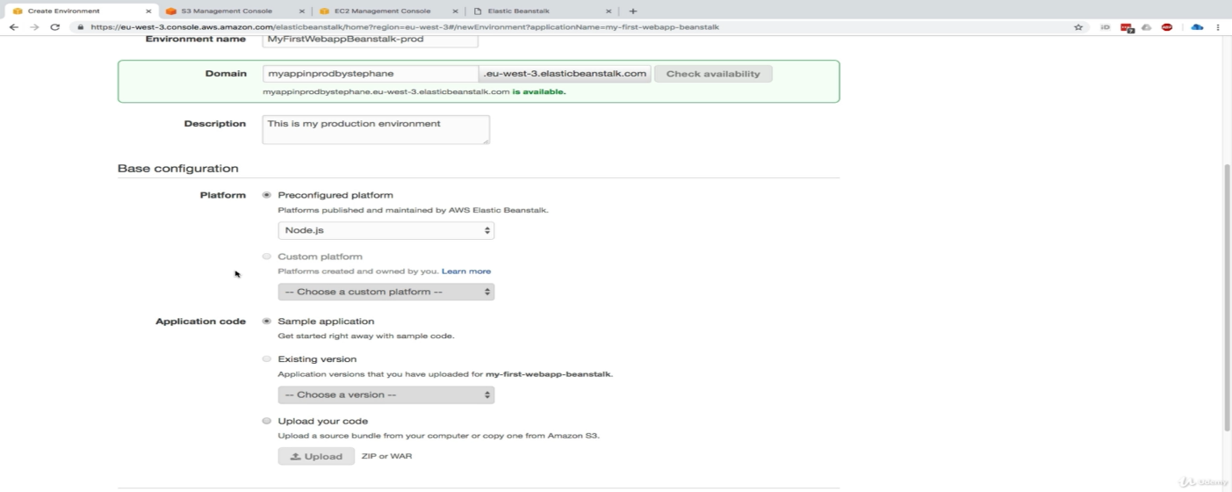
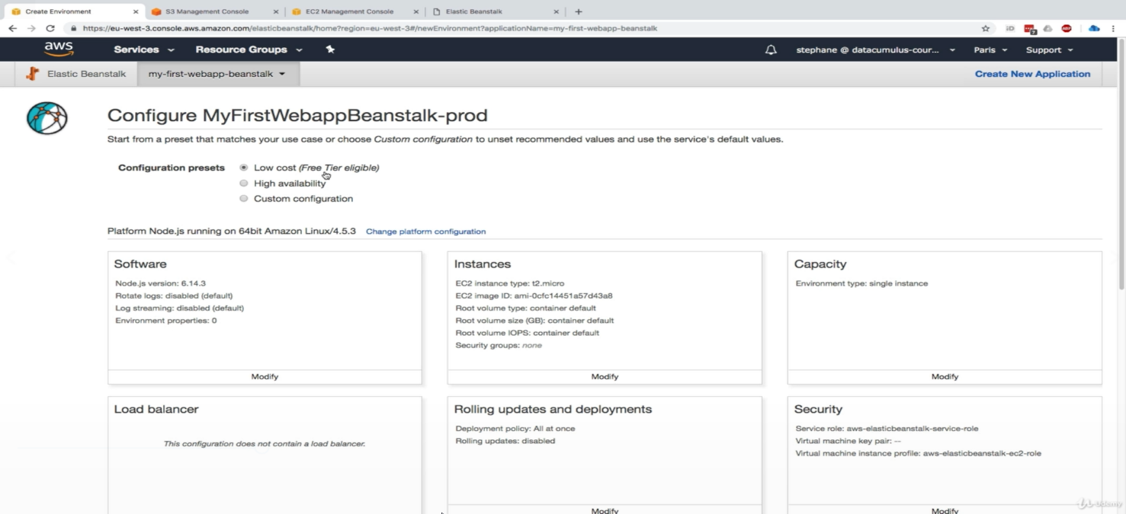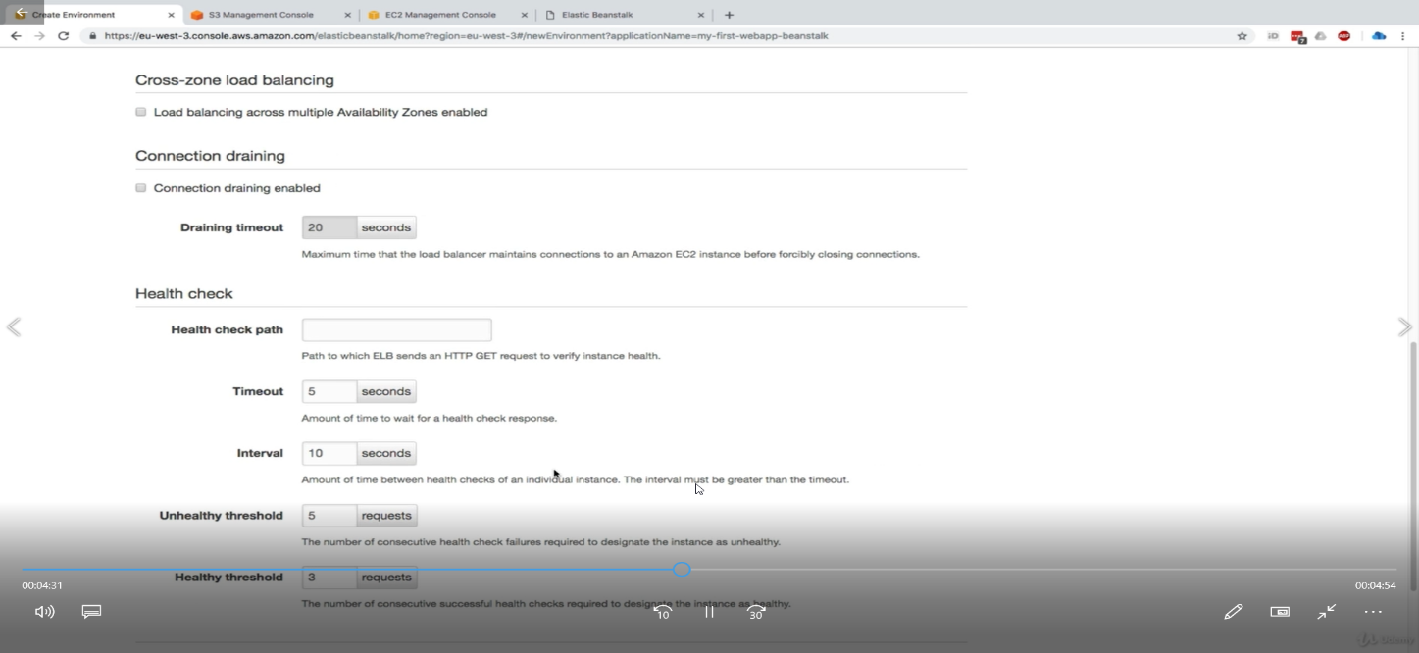
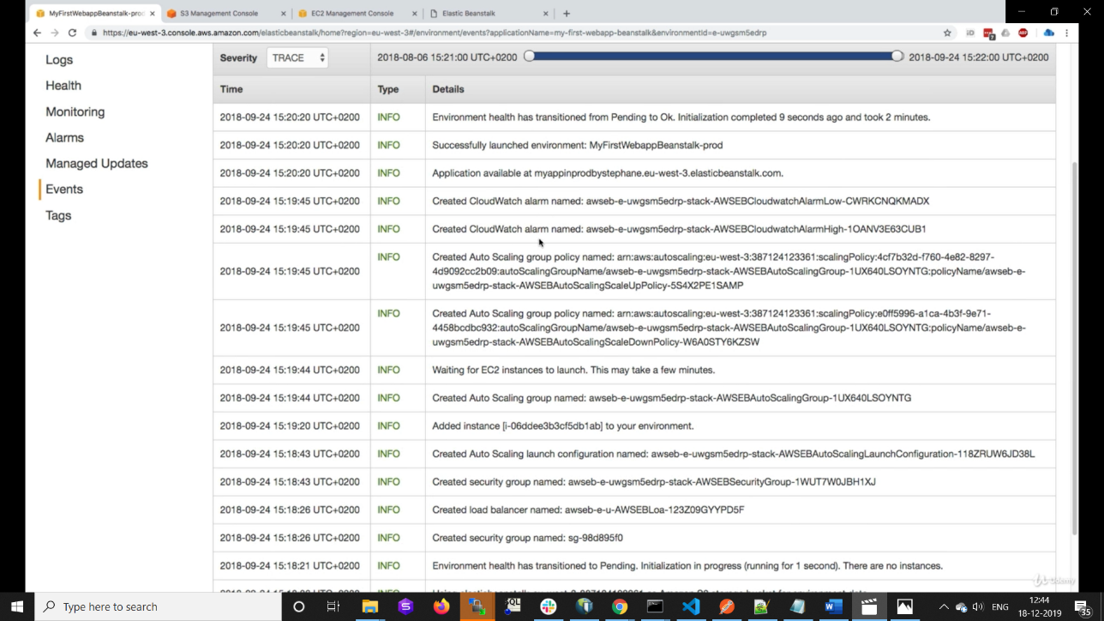`
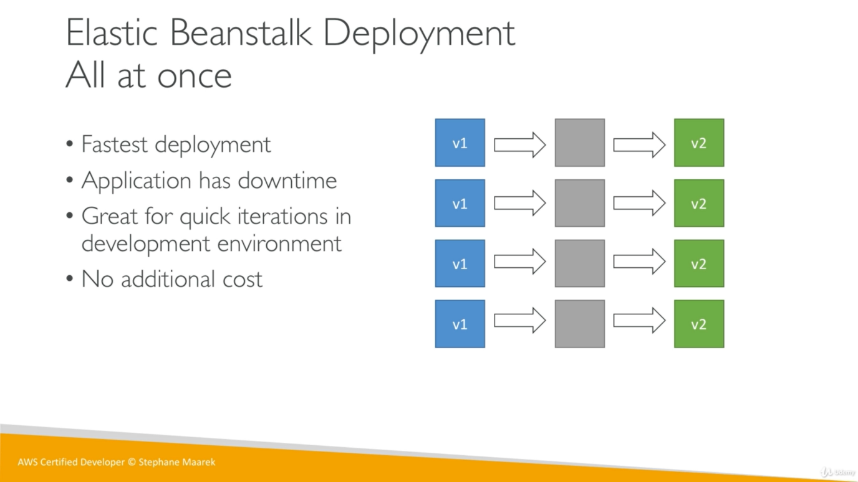
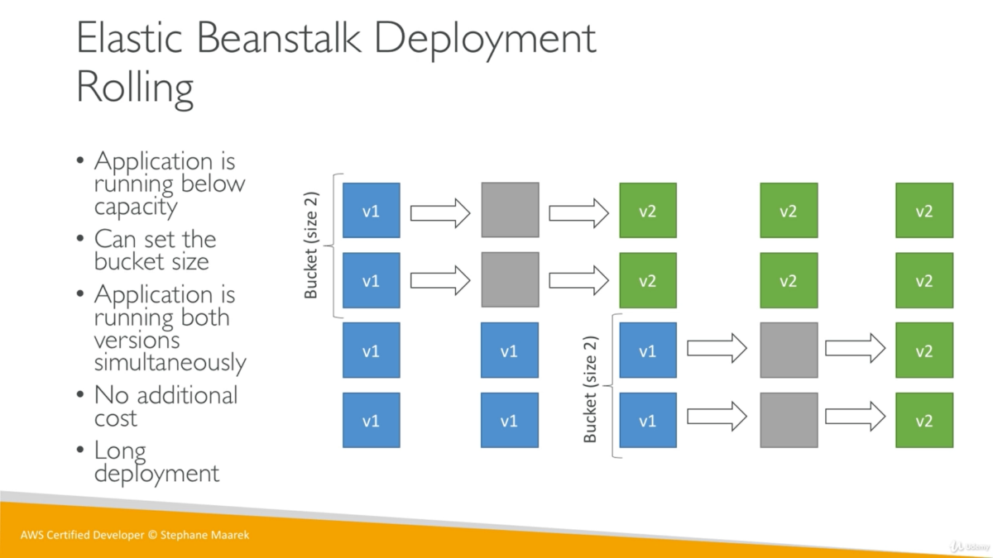
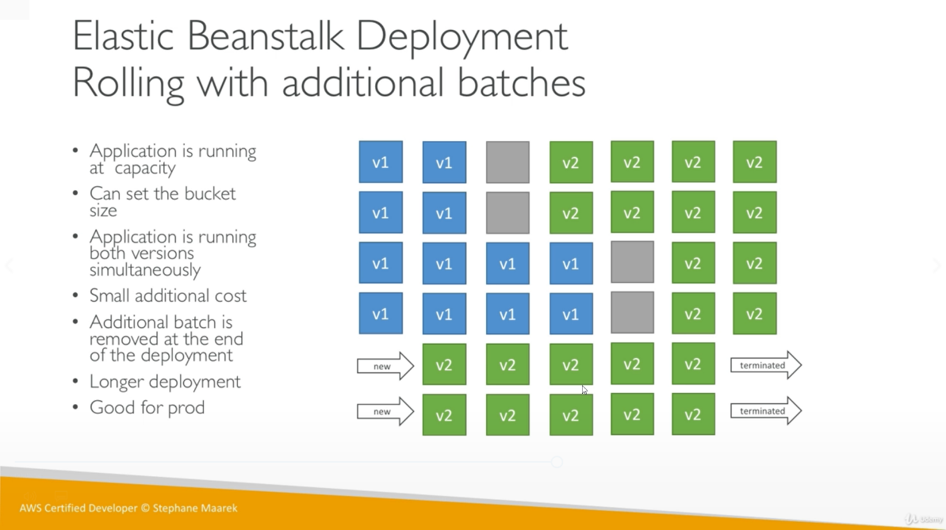
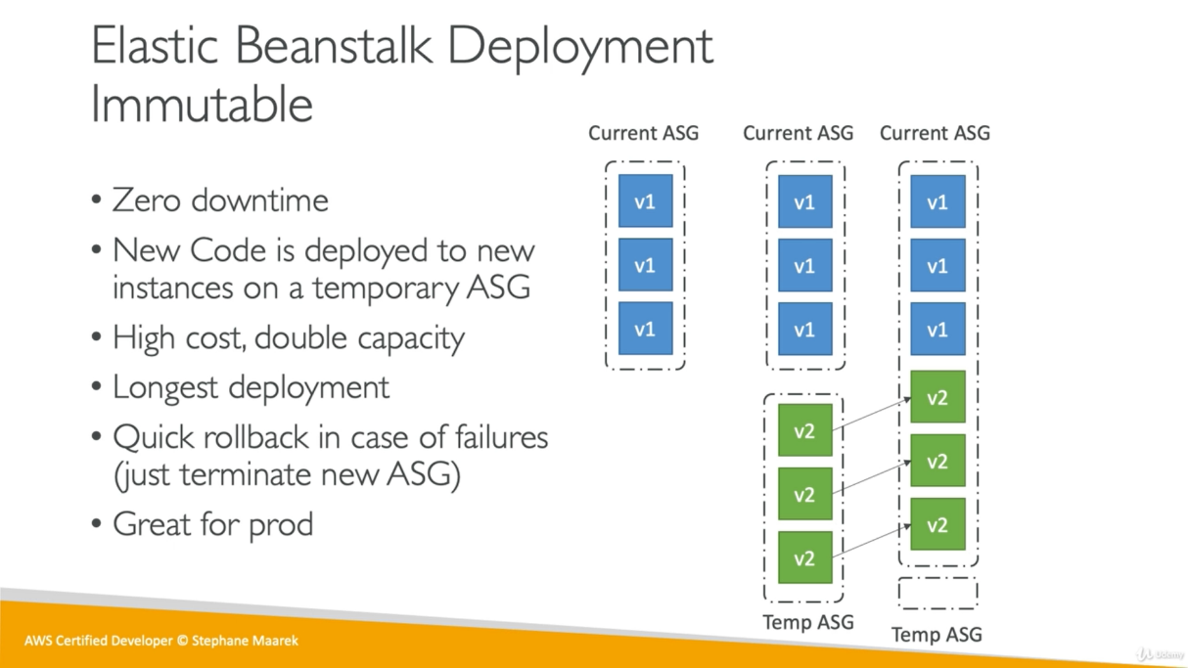

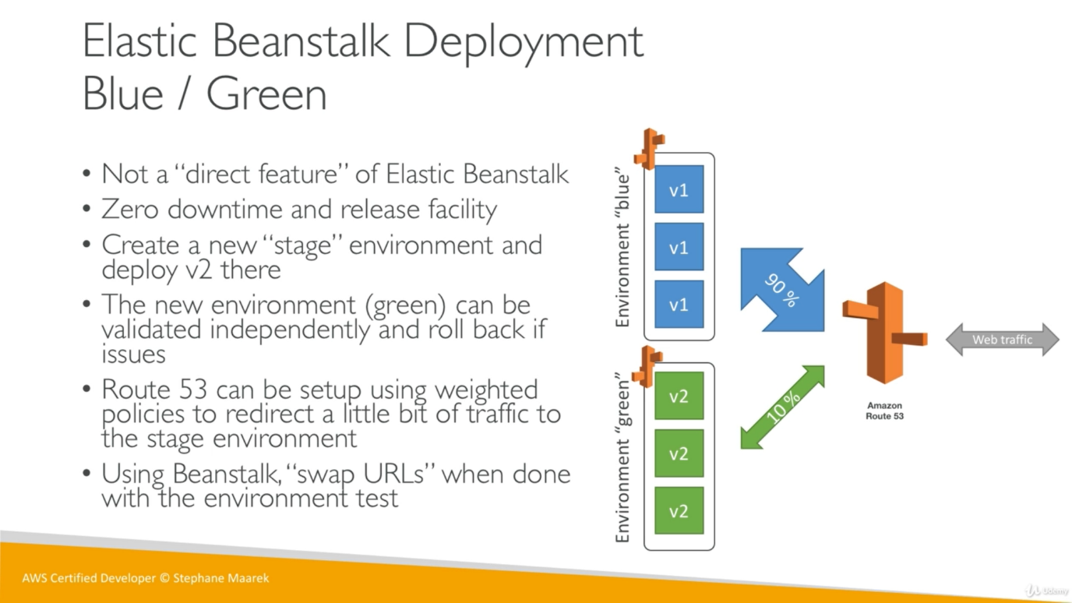
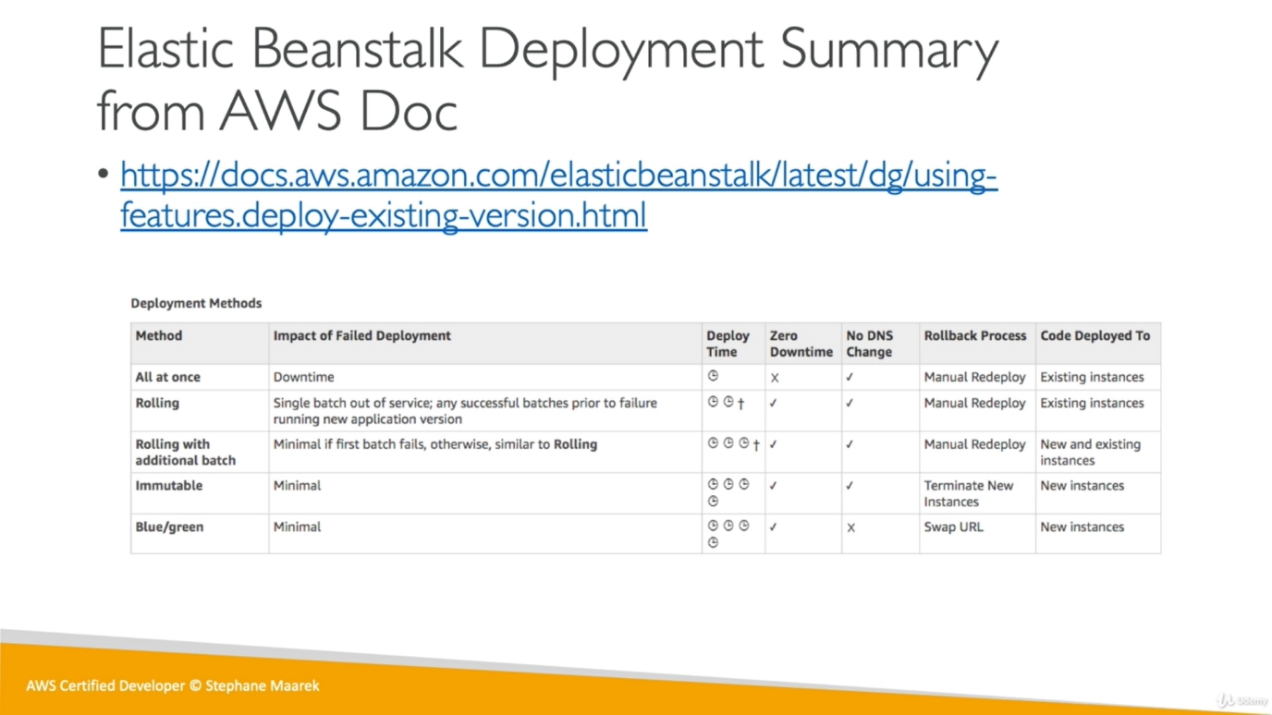
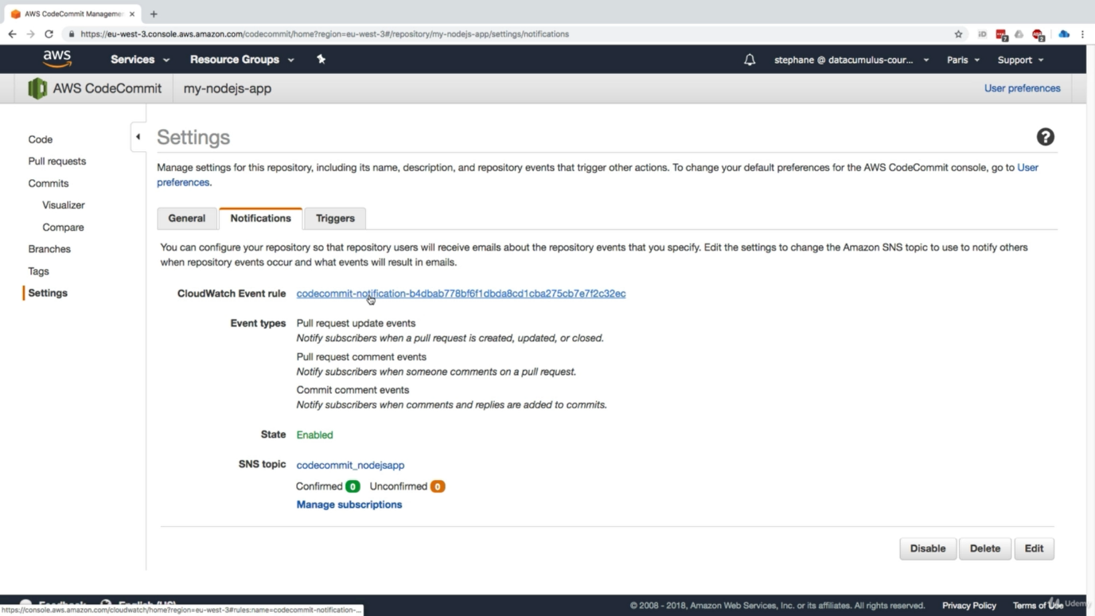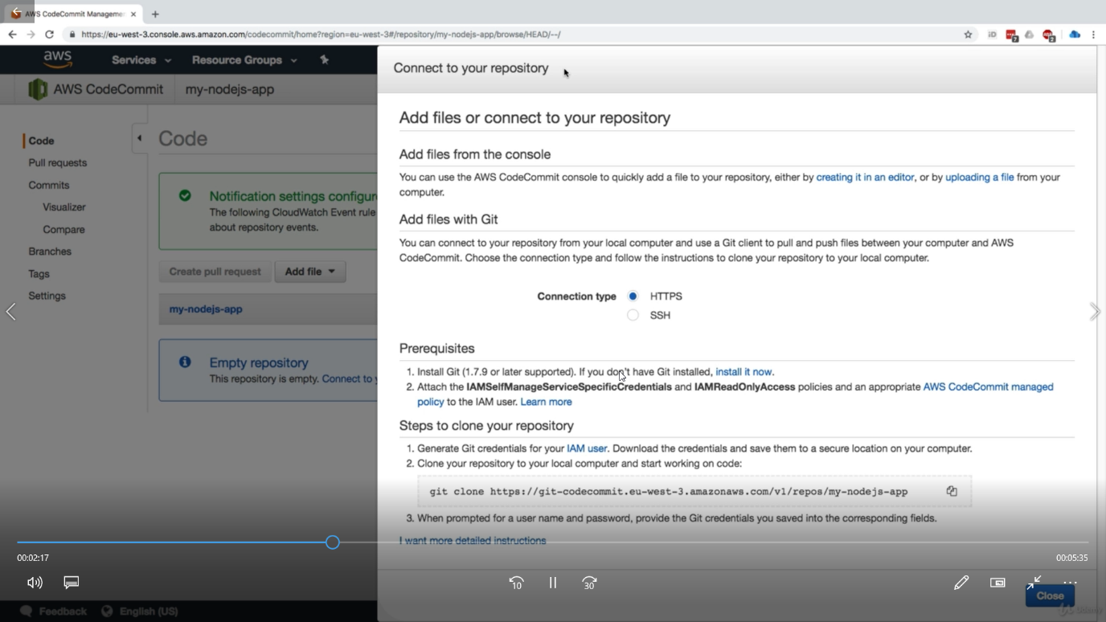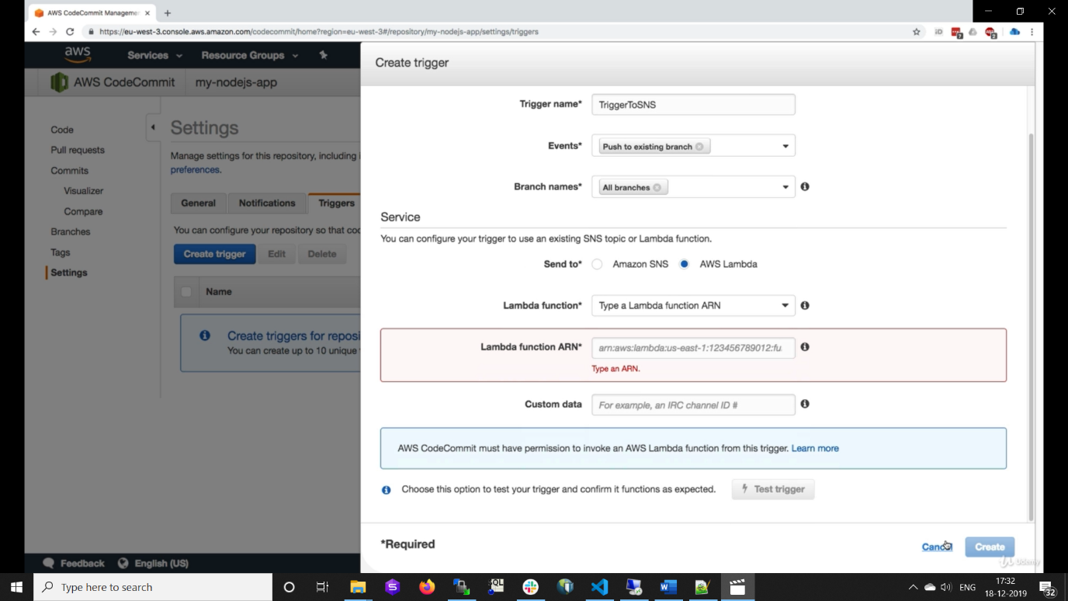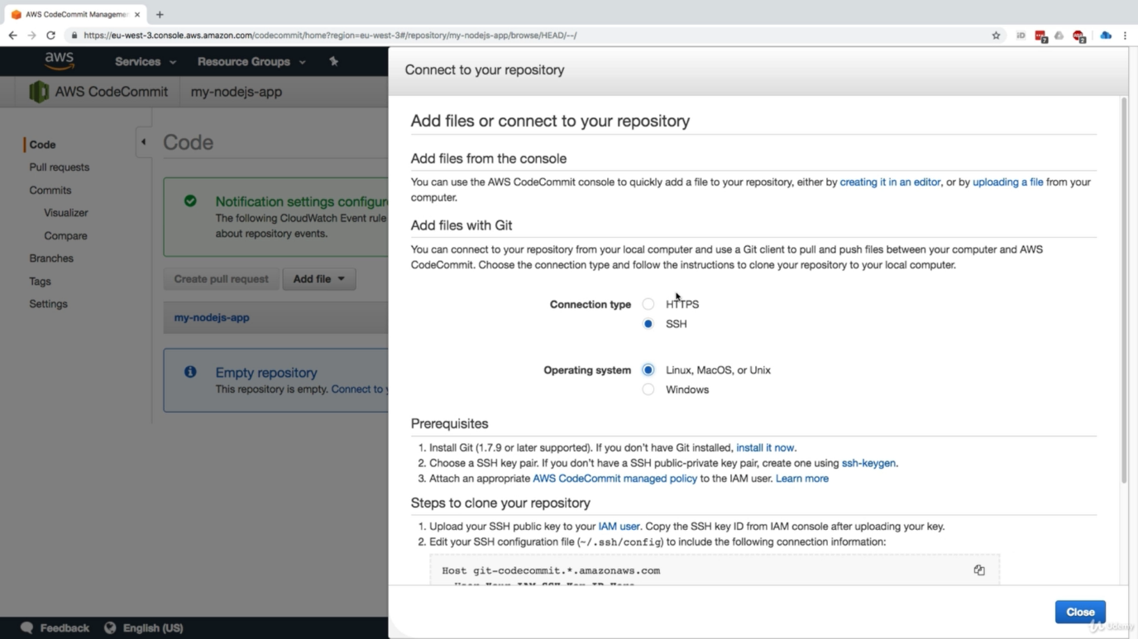
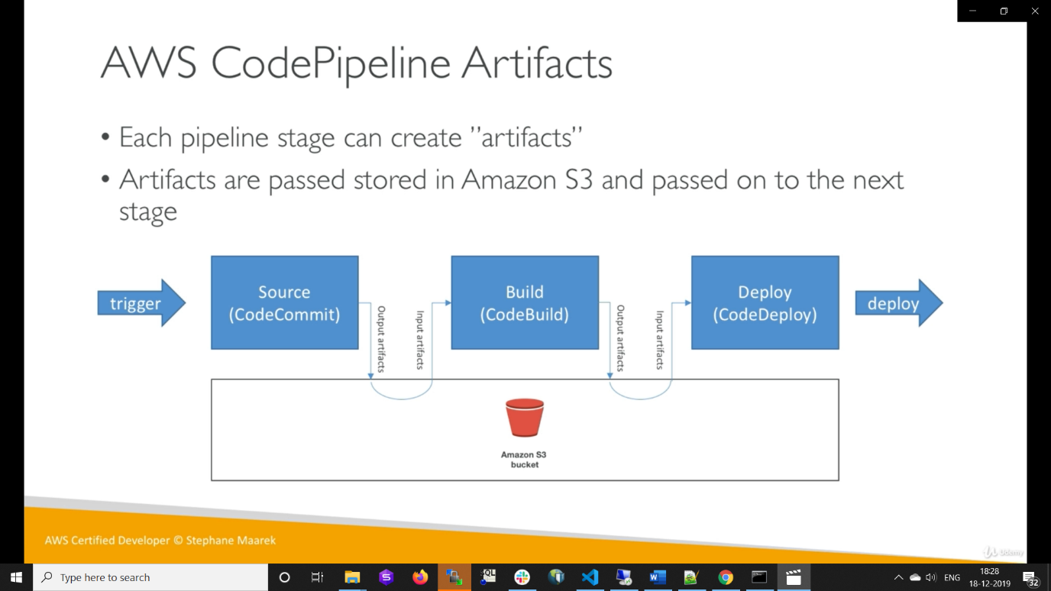

We can use cache as aws 3 to improve performance of codebuild
Buildspec.yml is required to build the code
Appspec.yml is needed for codedeploy

